**Moncton Lab Spring Symposium**

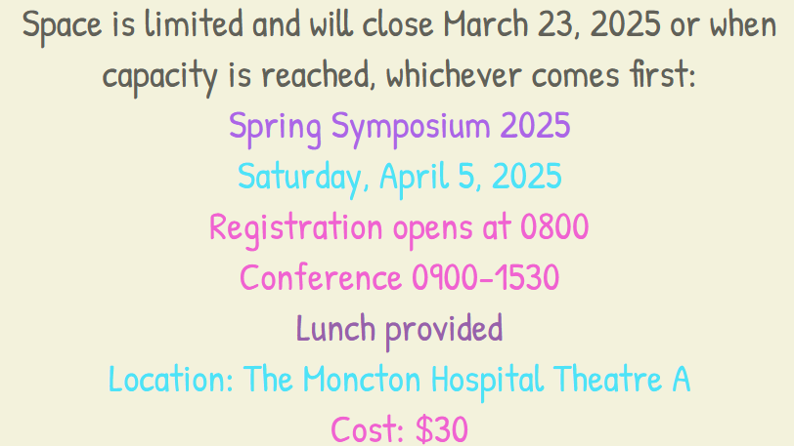

[REGISTER NOW](https://forms.office.com/Pages/ResponsePage.aspx?id=736L4AG1Z0qe0Afji_zO5-Xe4bmGVbJBqtHSu6tIQrlUOFFaQU9QRVg1NkpBUzMyNUVJSFgzWjBTUS4u)

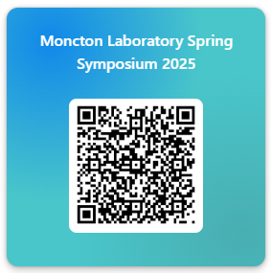

[SCHEDULE](https://monctonacademy.wixsite.com/moncton/schedule-horaire) AND [SPEAKERS](https://monctonacademy.wixsite.com/moncton/speakers-conferenciers)

